Binding method

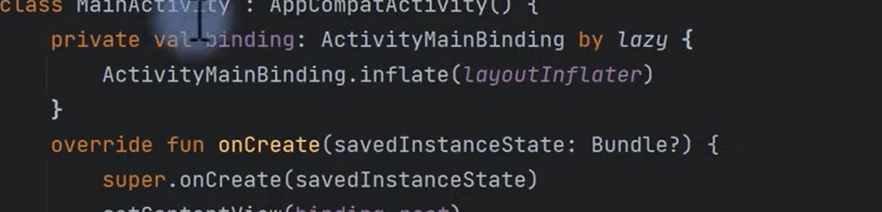

For webview we have to enable internet permission and also add webview in it and loadUrl function with http or https included in parameter with domain of web

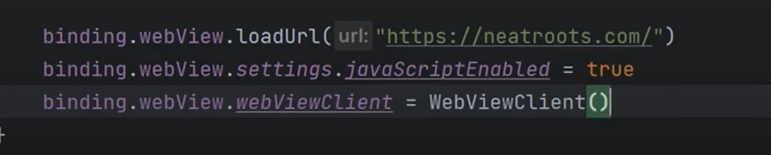

If we click, we go back but this will allow us to stay at same page even after coming back to app

